**Sodus United Third Methodist Church Welcomes You**

**October 19, 2025 – 10:30 a.m.**

**Nineteenth Sunday After Pentecost**

**LAITY SUNDAY**

**We Gather to Be the Church in Worship**

**! indicates to please stand if you are able**

Prelude/Gathering:

Receiving the Light of Christ into our Sanctuary:

Announcements:

Call To Discipleship:

**L** and **P:** **We have gathered once again, Lord of all and Lord of us. We come to lift our prayers, and to sing your praises once again. We come to ask and hope and long to see your justice in the land. We worship in that hope and will work in that Spirit, Amen.**

**! Hymn of Praise: “As The Deer” TFWS #2025**

Morning Prayer: **(In Unison..)**

**Gracious and persistent God, We gather today in your presence, mindful of your promises and your grace. You call us to pray always and not to lose heart, as we hear in the parable of the persistent widow. Open our ears to hear your word and soften our hearts to receive your truth. We confess that we often grow weary and lose hope when our prayers seem to go unanswered. Forgive our lack of trust and rekindle within us a spirit of stubborn faith. Embolden us to be persistent in our prayers and in our quest for justice. Just as the widow sought justice from the unjust judge, give us the courage to speak for those who have no voice. Remind us that you, our heavenly Parent, are not like the unjust judge, but are a loving and righteous God who will hear our cries and bring about justice. Meet us in this time of worship, renew our spirits, and strengthen**

**our faith. Help us to remember that our persistence in** **prayer and action is a sign of our trust in your steadfast love. We pray this in the name of your Son, Jesus Christ, who taught us to pray without ceasing, Amen.**

Praises and Joys / Birthdays and Anniversaries:

Time For Young Disciples: **“Pray and Don’t Give Up”**

**SCRIPTURE**

L: The Lord be with you. **P: And also, with you.** L: Let us pray. **L** and **P: Faithful God, we wait in hope for you to speak. Come to us in Scripture read and proclaimed. By the power of your Holy Spirit, increase our faith that we may do all we are commanded to do according to your glory, Amen.**

Old Testament Reading: Jeremiah 31:27-34 *Liturgist* Responsive Reading: Psalm 119: 97-104 (Insert) *Liturgist*  **! Gloria Patri: (In Unison..) UMH #70 Glory be to the Father, and to the Son, and to the Holy Ghost; as it was in the beginning, is now, and ever shall be, world without end, Amen, amen.**

Gospel Reading: Luke 18:1-8 *Liturgist*  L: This is the word of God for the people of God. **P: Thanks be to God.**

**! Hymn of Preparation: “Come and Fill Our Hearts” TFWS #2157** New Testament Reading: 2 Timothy 3:14-4:5 *Dale Davis*

Time For Mature Disciples:  **“Are You the Persistent Widow?”**

Preparing to give Tithes and Best Offerings: **(In Unison..)**  **Persistent and just God, you do not turn away when your people cry out. Receive these gifts as acts of our faith-faith that keeps moving, faith that keeps hoping, faith that keeps working for justice, even when the world says it is too late or too little. Make us a people who do not lose heart. Shape our prayers into action and our generosity into grace, until your kingdom comes on earth, as it is in heaven. In the Name of Christ, who still stands and knocks, Amen.** (Luke 18:108)

Prayer Requests and Pastoral Prayer and **Lord’s Prayer: (In Unison..):** **Our Father, which art in heaven, hallowed be Thy name; Thy kingdom come...** ! Hymn: Cares Chorus TFWS #2215

**! Hymn: “It’s Me, It’s Me, O Lord” UMH #352**

**Sodus United Third Methodist Church Celebrates LAITY SUNDAY Nineteenth Sunday After Pentecost** **October 19, 2025**

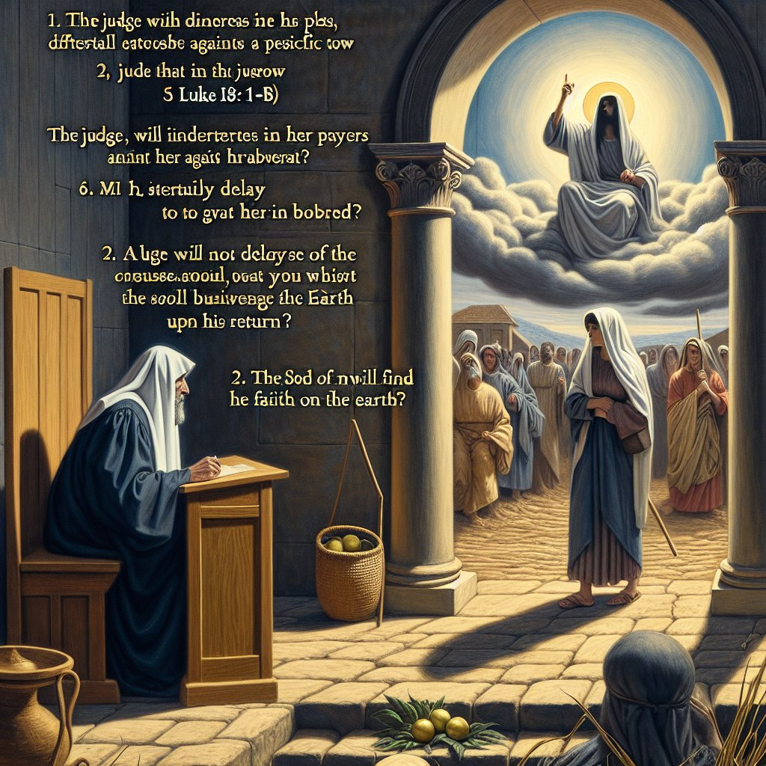

**Persistence. What does that mean for us in worship?**

! Closing Prayer **(In Unison..) Holy God, As we depart from this place, we carry with us the lesson of the persistent widow: to pray always and not to lose heart. We confess that our faith sometimes falters, that we grow discouraged in the face of injustice, and that we can lose hope when our prayers seem to go unanswered. Forgive our impatience and strengthen our resolve. Just as the persistent**

**widow sought justice from an unrighteous judge and received it, we trust that you, our righteous God, will hear and answer the cries of your people. We pray for all who face oppression and adversity, that they may be filled with persistent faith. Move us from simply praying for justice in the world. May we have the courage to stand with the vulnerable, to speak out against injustice, and to work tirelessly until your kingdom of love and righteousness is fully realized. Watch over us, guide us, and**

**empower us with your Holy Spirit. We pray this in the name of Jesus, who shows us the way of unwavering faith and love, Amen.**

Benediction with Blessings: May you continually wrestle with prayer. May you beseech the door of heaven with shameless boldness. May your prayers produce, in you, a countenance of joy, a gracious demeanor, and a peaceful heart. And may the God of hope, fill you with all peace, that you may abound in hope, assured that your prayers are heard by a loving and gracious Father. Go in faith and love, Amen.

Taking the Light of Christ out of our Sanctuary:

Postlude: “Go Now In Peace” UMH #665

**Interim Lay Servant:** Dale Marie Davis

Cell Phone: (315)398-0251

Email Address: [ddavis@caafl.org](mailto:ddavis@caafl.org)

When sharing a prayer concern or information of someone in need of a pastoral visit, please provide me with their contact information, and I will pass along to Rev. David B. Herrmann (315-460-6758) or Pastor Linda Glantz. Thank You!

Name:

Address:

Phone Number:

Email Address:

Please include your contact information in case Rev. David B. Herrmann or Pastor Linda Glantz should need to contact you for clarification.

**Responsive Reading: Psalm 119:97-104**

**O Mem**

L: **97** Oh, how I love your law! I meditate on it all day long.

**P: 98 Your commands are always with me and make me wiser than my enemies.**

L: **99** I have more insight than all my teachers, for I meditate on your statues.

**P: 100 I have more understanding than the elders, for I obey your precepts.**

L: **101** I have kept my feet from every evil path so that I might obey your word.

**P: 102 I have not departed from your laws, for you yourself have taught me.**

L: **103** How sweet are your words to my taste, sweeter than honey to my mouth!

**L** and **P: 104 I gain understanding from your precepts; therefore I hate every wrong path.**

**Prayer of Persistence**

God of Justice, we know that in this hard world there are judges that neither fear God nor respect their fellow men.

But you call us to remember the woman who gave one a hard time, crying out to him day and night, until he changed his mind – her sheer stubbornness.

And we celebrate all those, women and men, who persist in the cause of right; who will not keep quiet; who insist on raising the issues, again and again; who campaign for unpopular causes, write letters, send emails, sign petitions: people round the world who pick up their pens or take to the streets – and young girls determined to go to school

We celebrate them: steadfast, down-to-earth, blessed with both stubbornness and courage, to change the world. Amen.

**LAITY SUNDAY**

Jesus once told a story about a widow who kept asking a judge for help. At first, the judge ignored her, but she didn’t give up. She kept coming, asking, and persisting until finally, the judge gave her justice—not because he cared, but because she refused to stop asking.

Jesus explained this story so his followers would understand the importance of praying without losing heart. If even an unjust judge will eventually respond to persistence, how much more will a loving God listen to the faithful prayers of his people? This parable isn’t just about prayer—it’s about faith that keeps showing up. It’s about trust in God that refuses to quit, even when answers don’t come quickly. Faith is more than words; it is persistence, courage, and a willingness to live out our trust in God through daily action.

That is what [**Laity Sunday**](https://www.umc.org/en/how-we-serve/umcgiving/special-sundays/awareness-special-sundays/laity-sunday) is all about. Many people think the work of the church belongs mainly to pastors or clergy. But in the United Methodist Church, we recognize that the majority of the church’s ministry is lived out through lay people—the everyday disciples who follow Christ in their homes, workplaces, schools, neighborhoods, and communities. Laity are teachers, caregivers, volunteers, advocates, business leaders, parents, and friends. They are the ones who persist in living out the Gospel every day, not just on Sundays. Laity Sunday reminds us that the church is built not on one person’s calling, but on the shared faithfulness of many. It’s a day to celebrate, encourage, and support all God’s people who persist in prayer, service, and witness. Think about the widow again. She didn’t have power, wealth, or status.

What she had was persistence. She kept showing up, and that persistence brought justice. The same is true of the church today. The work of God’s kingdom is advanced not only through big, dramatic moments, but through steady acts of love, service, and witness carried out by faithful people day after day.

Your prayers, your service, your generosity, your voice—they all matter. They are part of the persistent witness that makes Christ known in the world. Laity Sunday is our chance to pause and say: thank you to the countless laypeople who persist in faith and who embody Christ’s love in ordinary but powerful ways.